Postmortem Report

Mark Graven

Southern New Hampshire University

**Contents:**

**RTM / Program Logic --------------------------------------------------------------- [****Page 3****]**

**Bug Testing / Reporting --------------------------------------------------------------- [****Page 5****]**

**Runtime Error Handling --------------------------------------------------------------- [****Page 5****]**

**Control Setup/Interface --------------------------------------------------------------- [****Page 6****]**

**Image References --------------------------------------------------------------- [****Page 7****]**

**What went right**

1: **Simple but identifiable “Fuzzies”**

While the fuzzies aren’t exactly fuzzy, in the strictest sense, the two models chosen to represent fuzzies were custom made and are clearly identifiable to virtually all players. This becomes particularly evident when the player initiates the objective/quest at the farm and they are prompted to pick up X amount of Giraffe fuzzies, and Y amount of Pig fuzzies. With that information on the screen, the user can clearly identify which is which, and is able to make the decisions to chase them down.

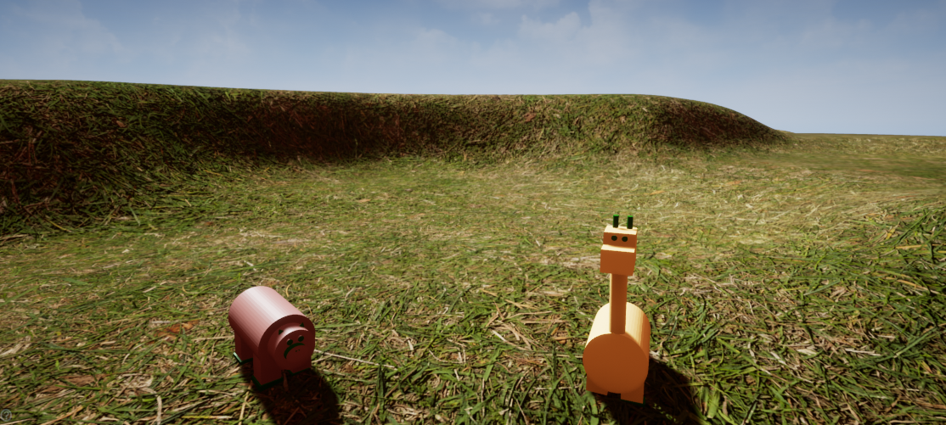

**2: Field themed Landscape**

The original concept of the gameplay field was simple enough and was done by creating a large enough navigable area for the player to chase down the fuzzies.